# Tomosynthesis Machine Learning

**Abstract:**

Breast cancer is the most common cancer in women in both developing and developed areas worldwide. Tomosynthesis, also digital tomosynthesis, is a method for performing high-resolution limited-angle tomography at [mammographic](http://en.wikipedia.org/wiki/Mammography) dose levels. Digital breast tomosynthesis (DBT) can provide a higher diagnostic accuracy compared to conventional mammography for breast cancer screening. In this project, we focused on developing computer aided diagnosis algorithms based on tomosynthesis images.

Mostly, we focused on extracting suspicious areas and providing confident scores from the screening images where speculated masses, micro calcifications, and bilateral asymmetric occur. In mass detection, the main techniques used are gabor wavelet transformation, level-set segmentation and multi-instance learning. To detect micro calcification, we mainly use the Laplacian of Gaussian filter plus preprocessing and post analyzing. For bilateral asymmetric analysis, we apply the thin plate spline registration algorithm and a set of region comparison metrics.

Despite the lacking of enough training data, our work shows promising initial detecting results in tackling mass, calcification, and asymmetric within the same framework. However, future work is needed to improve detection accuracy and reduce false positive, with rich training information.

**John Ellenberger**

**Yanbin Lu**

**SAP Labs LLC**

## Introduction

Breast cancer is the most common cancer in women in both developing and developed areas worldwide. It is the principal cause of death from cancer among women globally. Breast cancer is the development of cancer from breast tissue. Breast cancer occurs when a malignant (cancerous) tumor originates in the breast [1].

Tomosynthesis, also known as digital tomosynthesis, is a method for performing high resolution limited angle tomography at mammographic dose levels. Conventional digital mammography produces one image of overlapping tissue, making it difficult to detect cancers. Performed with digital mammography using the same scanner, breast tomosynthesis takes multiple images of the entire breast. It provides the possibility of detection through layers of tissue and examination areas of concern from all angles [2, 3, 4].

There are multiple major symptoms visible from the tomosynthesis images in the early stage of breast cancer, including spiculated mass, clustered micro-calcification, architectural distortion, bilateral asymmetric, etc. [5]. Each of them will be further discussed in Section 2.

In this project, we focus on developing an automatic computer aided detection framework based on computer vision techniques to detect early sign of breast cancer through digital tomosynthesis. The method includes algorithms detecting spiculated mass, micro calcification and bilateral asymmetric.

In Section 2, descriptions of multiple early signs of breast cancer are given in details. The methodology designation and algorithms applied are introduced in Section 3. We conclude the article with Section 4 and provide more thought for future works.

## Background

There are multiple major symptoms visible from the tomosynthesis images in the early stage of breast cancer, including spiculated mass, clustered micro-calcification, architectural distortion, bilateral asymmetric, etc.

Spiculated mass: A spiculated mass is a cluster of barbed tissue that is one of the primary indicators of cancer. Rather than a smooth lump, it has spicules or thin, elongated pieces of tissue sticking out from its perimeter. Masses with irregular shape usually indicate malignancy and regular shaped masses such as round and oval very often indicate a benign change [5]. An example of benign and malignant mass tissue is as shown in Figure 1: A schematic illustration is given as well in Figure 2.

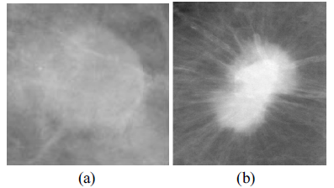

Figure : Example of benign and malignant mass tissues: (a) benign mass tissue; (b) malignant mass tissue

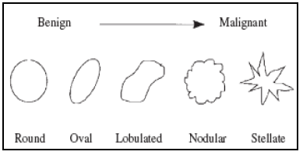

Figure : The Progression from benign mass to malignant mass

Micro calcification: Breast calcifications are calcium deposits within breast tissue. They appear as white spots or flecks in the tomosynthesis images. There are two types of calcification, macro-calcification and micro-calcification. Macro-calcifications usually show up as large white dots or dashes. They're almost always noncancerous and require no further testing or follow-up, while micro-calcificatio usually show up as fine, white specks, similar to grains of salt. Clustered irregular micro-calcifications usually assemble as a malignant pattern [5, 6]. An example of clustered micro-calcifications is given in Figure 3:

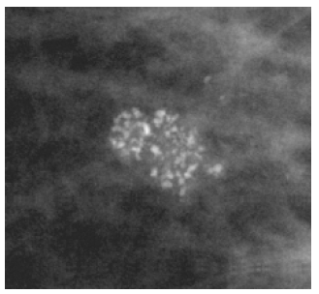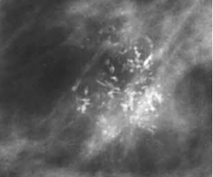

Figure : Example of clustered micro calcification

Architectural distortion: Architectural distortion is the third most common mammographic appearance of non-palpable breast cancer, representing nearly 6% of abnormalities detected on screening mammography. Architectural distortion is defined as an appearance in which “the normal architecture of the breast is distorted with no definite mass visible, this includes speculation radiating from a point and focal retraction or distortion at the edge of parenchyma” [5, 7]. Examples of architectural distortion are given below in Figure 4.

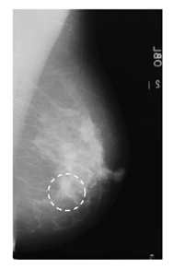 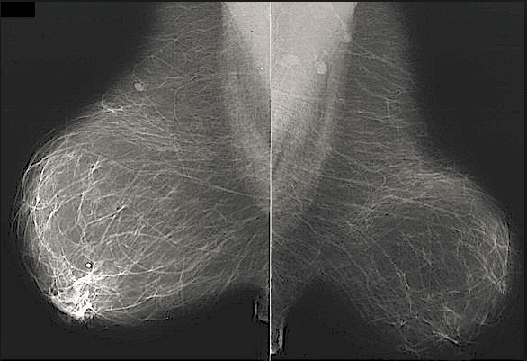

Figure : Example of architecture distortion

Bilateral asymmetric: Bilateral asymmetry, i.e. asymmetry of the breast parenchyma between left and right breast, may indicate breast cancer in its early stage. According to ACR's (American College of Radiology) Breast Imaging Reporting and Data System there are two types of bilateral asymmetry: global asymmetry and focal asymmetry. Global asymmetry is defined when a greater volume of fibroglandular tissue is present in one breast compared to the corresponding area in the other breast and focal asymmetry is circumscribed area of asymmetry seen on two views, but it lacks the borders and conspicuity of a mass. Focal asymmetry is usually an island of healthy fibroglandular tissue that is superimposed with surrounding fatty tissue [5, 8]. An example of bilateral asymmetric is given in Figure 5.

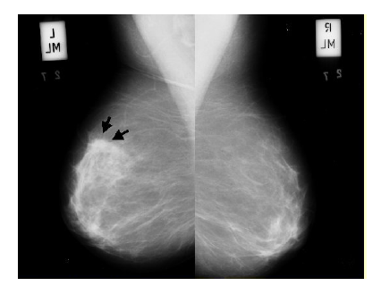

Figure : Example of bilateral asymmetric

## Methodology

In this project, the method focuses on detecting early sign of breast cancer by detecting the existence of spiculated mass, clustered micro-calcification and bilateral asymmetric. Given that the configuration of spiculated mass and micro-calcification is dramatically different as described in the previous chapter, the method deals with the two types of object using different techniques. In our method, most of the steps are preceded based on individual 2d slices. The frame work of the method is given in Figure 6 and described as well in the following paragraphs.

As a standard procedure, preprocessing of images is conducted before the application of detection algorithms. In our method, a combination of Anscombe Transform and Adaptive winner filter is applied to remove Poisson distributed noises from X-ray images. We also provide the option of contrast enhancement using the histogram equalization algorithm. A step of skin line and artifact removal is conducted before going further to the next level. Detail explanation of the preprocessing procedure and relevant selection of parameters are further described later in this chapter.

The detection of spiculated mass includes several steps. In the first step, a Gabor filter bank with kernels in multiple orientations and multiple scales is adopted to detect the possible existence of mass-like object. Regions of interest are localized from each image slice by analyzing the filter’s response function. In the second step, a level set segmentation algorithm is applied after deriving the ROIs, the center of each ROI is given as a seed for the snake model to propagate. A trivial but important trick between the previous two steps is to remove the pectoral muscle area (We used Hough transform to detect the pectoral line). In the third step, features are extracted from each of the ROIs before and after segmentation. Classification is done in the last step combining all ROIS from all slices over the entire image stack. Again we will describe in extreme detail later in the chapter.

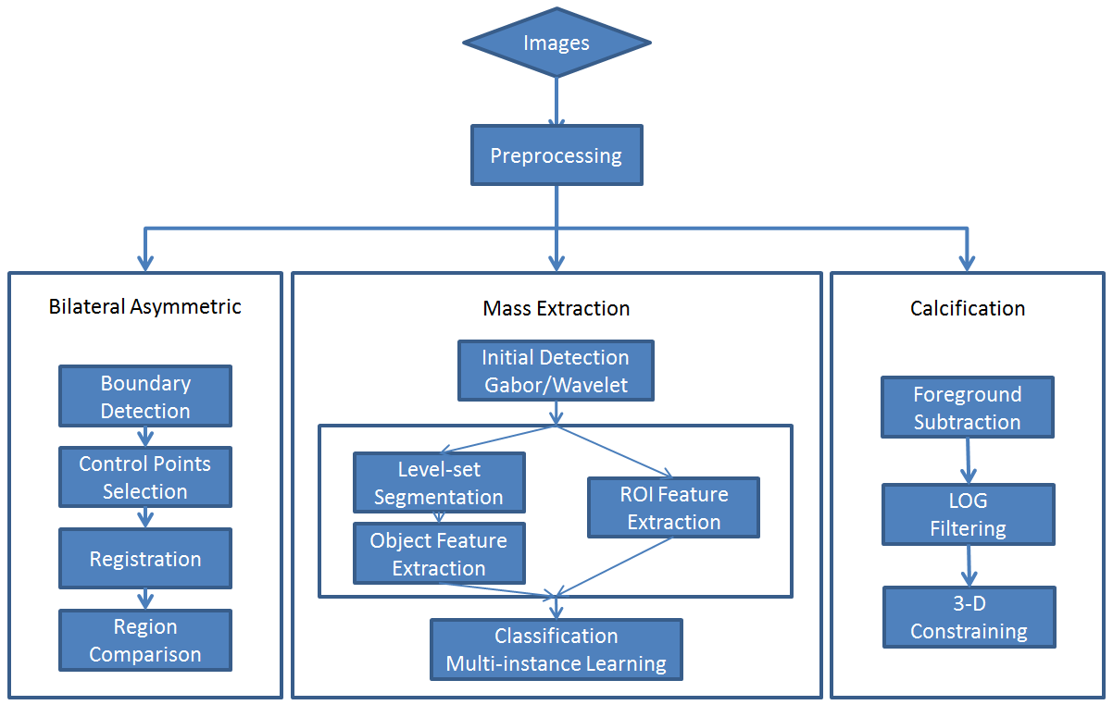

Figure : The framework of our project methodology, including Mass Extraction, Micro-calcification Detection, and Bilateral Asymmetric Analysis

The micro-calcifications are existed as clusters of tiny bright blob-like objects in the images; therefore, the main technique we use in this method is the Laplacian of Gaussian filter. Besides this, a step of foreground extraction is applied based on given knowledge. A post-processing step is also adopted to trim the detected suspicious calcification. In the post processing step, information from adjacent slices are used as spatial constrain given the nature that micro-calcifications usually exist in a scattered cluster.

When global or local bilateral asymmetric occur in the two sides of the breast, it might be an early sign of the breast cancer. We detect and analyze bilateral asymmetric following the given steps: contour detection, where the boundary of the breast is extracted; fiducial points selection, these are the sets of points in the image controls the alignment displacement; and region comparison, where we compute the similarity of corresponding regions from both side of the images.

### Preprocessing

In the images of interest, there are few major problems need to be concerned before any analytical algorithms applied. The tomosynthesis images are created using low energy X-ray radiations. A typical characteristic of such images is that the noise is distributed as a Poisson distribution. Theoretically, any algorithms that stabilize the variance of a distribution will apply. In our project, we choose the combination of Anscombe transformation and adaptive Winier filter as a denoising procedure [9]. The Anscombe transformation transforms a random variable in a data dependent Poisson distribution into an approximate Gaussian distribution with additive data independent noise [10]. The Adaptive Winnier filter is then applied to remove the Gaussian distributed noises locally [11]. An inverse Ansocombe transformation following bring back the images to the original domain. Specifically the procedure is as follows:

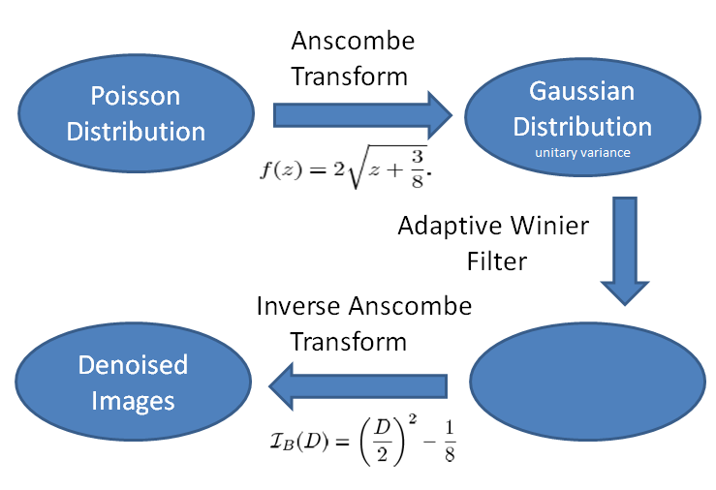

Figure : The preprocessing workflow and algorithms applied

In practice, users can adjust parameters to adapt to specific image datasets. For example, in the winier filter, the neighborhood size which defines the region of smooth can be adjusted, a default value of (5,5) is used in the project. There are multiple choices in terms of the inverse transform, for simplicity and computational efficiency; we choose the most practical yet unbiased form. An example of this procedure is as shown in Figure 8:

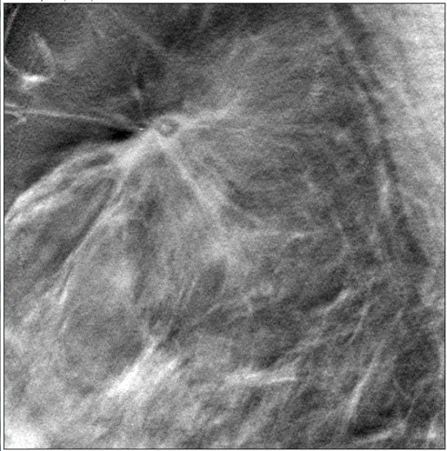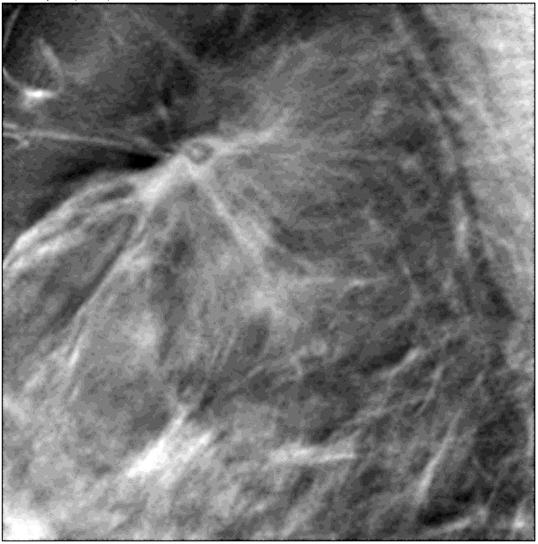

Figure : Image region before and after preprocessing

Another major problem with our dataset is the skin-line and artifact due to other processes. For example the skin-line (boundary of the breast) is always of high intensity and without being informative due to X-ray reflection in the imaging process. The existence of multi-boundary due to offset shift in reconstruction process also has significant effect in the following process. To avoid all those artifacts, we used a simple thresholding step to get rid of these areas.

In our dataset, typical image intensity values are distributed between 4,000 ~ 6,500, the background value of the image is 0. We used two thresholds to lineate the breast boundary and artifact. The lower threshold 2,500, defines the background and foreground, and the higher threshold 7,500 detects high intensity artifact mostly sitting in the top and the bottom of the image. The two binary masks are dilated so that not only the boundary and artifact are removes, but also the close neighborhood of the boundary and artifact are removed. The dilating element structured used is a disk structure with radius of 15 and 30 respectively. (Those are determined in a heuristic way, can be adjusted accordingly). Below in Figure 9 shows the result of boundary and artifact removal, the original image is also given on the left.

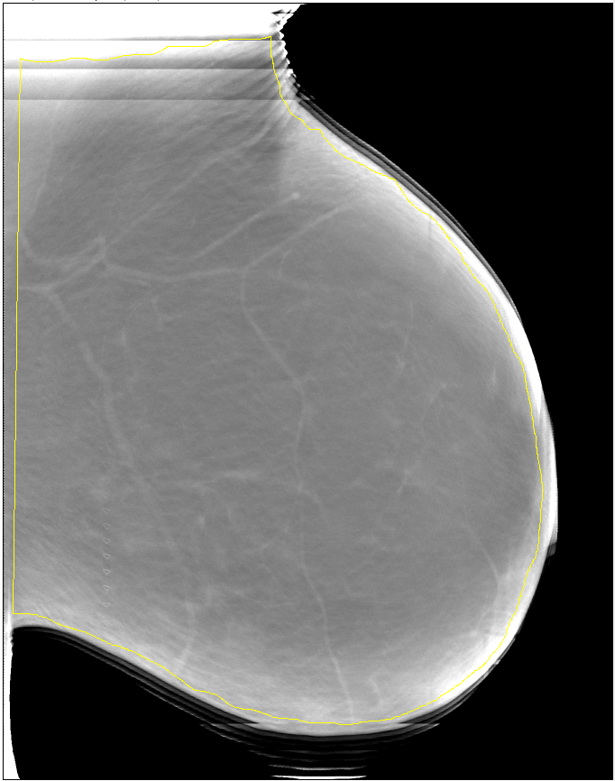 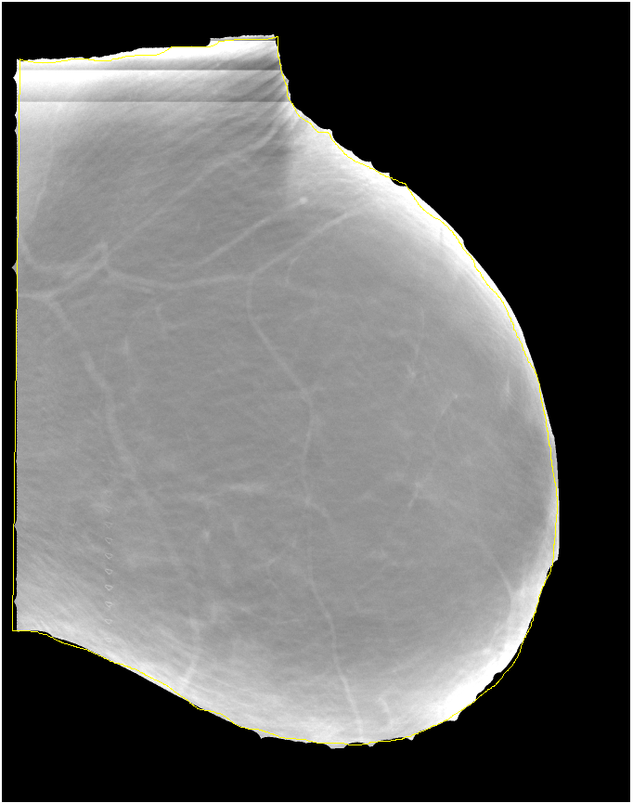

Figure : Image before and after boundary and artifact removal

### Mass Initial detection

Given the morphological characteristic of spiculated mass, which is a lump of tissue with spikes or points on the surface, we tend to detect objects with higher than average intensity and spike-like shapes. In this project, we use multi-frequency, multi-orientation Gabor filters as matching templates [12, 13]. The idea behind is: a centered blob with spike-like surface will responds with a high response to a Garbor kernel with certain frequency (frequency corresponds to the spike frequency), and it will responds to the kernel in rotating orientations. Thus, in a certain area of the image, if the response to a kernel and its rotating siblings are approximately and higher than the neighborhood area, it is highly possible that there is a spike-like blob object exist in this area.

Specifically, a few steps are involved to localize the coordinate of suspicious spiculated mass:

The first step is Gabor transformation. We created a Gabor filter bank with sets of kernels with different frequencies, scales, etc. In each kernel sets, filters share the same parameter configuration except for orientations. The images after preprocessing are convolved with all elements in the filter bank. An example of the kernel sets and response images are as shown in Figure 10 below:

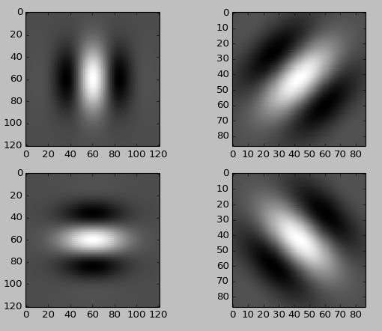 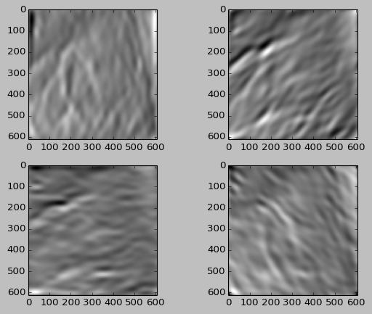

Figure : Gabor kernel with parameter (num_orientation = 4, scale = 5, frequency = 0.1, gamma = 1) and the corresponding responses

In the second step, we analyze the filters’ responses using a voting procedure. The analysis is all done in the coefficient domain. For computational efficiency, the responses are down sampled with each sample point being the integration of its neighborhood. The voting procedure is done based on both response magnitude and response orientation. For example, if we choose to use 8 orientations in each kernel set, there will be 8 response images correspondingly. The magnitude voting score of a pixel is the summation of the corresponding pixel from all 8 response images. The orientation voting score is calculated as follows: We first compute the ratio of each response image to the sum of the 8 response images (so the sum of the eight ratios is 1). If the ratio is greater than a certain threshold, then this orientation will add one voting point. In the scenario, the threshold is set to be 1/num_orientation. Finally, the voting score is calculated as a weighted sum of the magnitude score and the orientation score.

In the last step, we take a threshold of the final voting score and return the location where the voting score is above the threshold as suspicious region of interest. The final result of the initial detection is as shown in Figure 11 below:

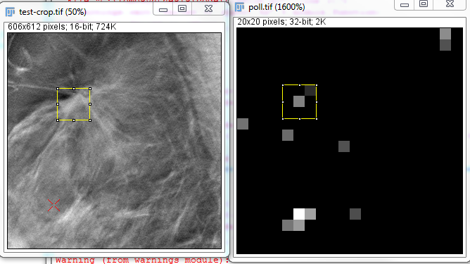

Figure : The original image region and the voting score image

However, there is a tricky step between the second and the third step, which is to remove the muscle area condition. The intensity in the pectoral muscle area is usually of higher than average value and evenly distributed. The voting score for this area is also higher based on the previous steps. Thus a removal will be necessary and enhance efficiency for the following processes. As is known, the boundary of the pectoral muscle is usually following a line structure in the image. We use the classic Hough transform to estimate the muscle boundary line and filtering out the muscle area [14].

### Mass segmentation

To fully capture the properties of each ROI, we applied a level set segmentation onto each of the ROI to extract mass morphological features. Specifically, we used a morphological snake model for evolving curves and surfaces in our project. This algorithm is aiming to provide a fast and stable approximation to the solution of the partial differential equations. It substitutes the terms of the PDE by the repeated application of morphological operators over a binary embedding function [15, 16]. In order to catch the boundary information as much as possible, in our method, we run the snake model twice by specifying different seed and evolving direction. On one aspect, a contour is evolving from the center of the ROI towards outward, and on the other hand, a contour is evolving from the border of the ROI towards the center. An example displaying the result of this step is as shown below in Figure 12.

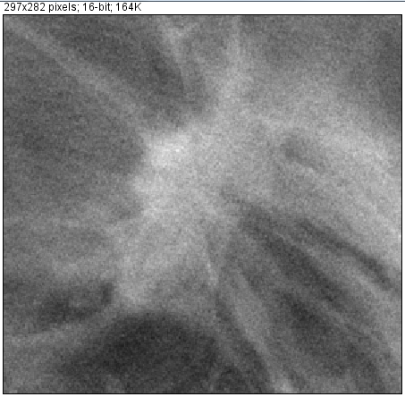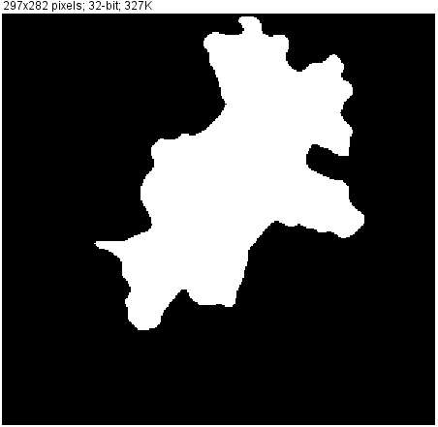

Figure : The original image region and its segmentation result

However, as is known, active contour is very sensitive to the parameters and image variance. In this project, parameters are carefully selected to suit the majority of the training images we have.

### Feature Extraction

To better describe each of the ROI and for further analysis. We extract sets of features based on the ROI grey level intensity, gradient information, and morphology of segmented objects. Given the characteristics of spiculated mass, we are trying to discover descriptive features that reveal the most representative information of a mass compared to normal tissue. Some of these features are designed for this project, and others are adopted from published works.

#### Intensity based features

This set of features is derived based on the intensity values of each ROI. The feature sets are calculated as follows:

The ROI is divided into a set of rings along the radius. The mean standard deviation of intensity is calculated within each ring and. After the mean and std vector are derived, we extract the statistic of the mean and std vector including the minimum, , the maximum , , the average , and standard deviation . Besides, we apply a linear regressive model to estimate the varying rate of mean and std value along the radius. The idea behind is in a typical spiculated mass, the average intensity decrease as the radius increase, and the standard deviation increase as the radius increase.

The same idea is used but the ROI is divided into circular sectors along the angle. Again the mean and standard deviation from each sector, and. The same after the mean and std vector derived, we extract the statistic of the mean and std vector including the minimum,, the maximum , , the average , and standard deviation .

The list of features from this category includes:

Table : A list of intensity based features

|  |  |
| --- | --- |
| Ring based | Circular Sector based |
|  |  |
|  |  |
|  |  |
|  |  |
|  |  |
| , |  |
|  |  |
|  |  |
|  |  |
|  |  |

#### Gradient based features

The same idea is used for gradient based features as for intensity based features. The first step is to calculate the gradient image of the ROI. Again we divided the ROI into rings and circular sectors as well. The difference lies in that instead of computing the statistics measurements, we took the percentage of pixels where the gradient magnitude above a certain threshold. The features are described as follows:

After the gradient image divided into rings , we calculate in each ring, the number of pixels with gradient magnitude above a threshold and gradient direction parallel with the radius, and further the percentage of high magnitude pixels are calculated for each ring as . Further, the maximum of percentage is picked as a feature. And the number of rings with its percentage greater than a threshold is picked as another feature denoted as .

Similar thoughts have been applied to circular sector based features. After the gradient image divided into circular sectors , we calculated for each sector the percentage of pixels where the gradient magnitude is above a threshold and the gradient direction is perpendicular to the radius . The percentage vector is sorted as a perpendicular index vector. Again the number of sectors with percentage higher than threshold is picked as a feature .

Above all, the gradient based features are summarized in the table below:

Table : A list of gradients based features

|  |  |
| --- | --- |
| Ring based features | Circular sector based features |
| . |  |
|  |  |

#### Segmented morphological features

Another set of features adopted in our project are the label image geometric features. These features are computed based on the segmented object located in the center of each ROIs. The most basic features being used are object area, central moments, eccentricity and perimeter. Advanced features computed on top of basic features include skewness and compactness. The formula for each of these features are given below in Table 3.

Besides, we have developed a group of features using a previous model (Rubber band stretch transformation, namely RBST) with slight modifications [17, 18, 19]. These features are computed as follows: An area along the contour of the segmented object is chosen. The volume of the the chosen area is approximately, where is the perimeter of the contour, while is the distance from the contour outside the contour. This area is transformed into a rectangular image, where row corresponds to all the pixels that are pixels away from the contour, and column corresponds to all pixels perpendicular to the contour at the pixel. In this way, the branches of the speculated mass are supposed to be captured in the columns of the matrix. Further, we take the second order gradient of this RBST images and counting the numbers of branches.

Table : A list of segmentation based geometric features

|  |  |
| --- | --- |
| Features | Explanation |
| area | Number of pixels within the contour |
| central moments |  |
| eccentricity |  |
| perimeter | Number of pixels on the contour |
| Euclidean skewness |  |
| compactness |  |
| Branch number |  |
|  |  |

#### Other features

We also adopted a lot of other features from previous related works, such example includes fractal dimensions, angular spread power [20], etc [21 ~ 24].

To estimate the fractal dimension, the two-dimension Fourier power spectrum of the ROI being processed was obtained. The 2D spectrum was mapped to the radial space from the Cartesian space, by resampling and computing weighted average of the four neighbors of each point for radial distances ranging from zero to half the sampling frequency and over the angles of [0, 179]. Then, the 2D spectrum in the space was transformed in to a 1D function by averaging as a function of the radial distance or frequency from the zero-frequency point over the range in [0,179] in angle. The spectrum is considered to be related to the radial frequency according to the model , The FD is then defined as .

### Classification

In the classification step, our goal is to reduce false positive detected in the initial detection step, using all the features we have extracted from previous sections.

Our data pool includes real spiculated masses, intersections of vascular structures, and irregular shaped high intensity objects. The key to the success of classification therefore relies on the dedicated selection of training samples. In the beginning of our projects, we train our classifier by real spiculated mass and absolute normal region. It turned out the classifier then classifies most of the test data into the cancer group. The reason for this is the test data after initial detection actually share more similarity with the cancer samples rather than with the normal region. For future record, the designer should select training samples with extra care not to bring absolute normal regions.

In this project, we choose out training set from the following scenarios: positive samples are chosen from speculated masses in real cancer cases; while negative samples are chose from the initial detected suspicious regions where cancer is absent.

Another reason brings us to the classification algorithm we are using is diversity in clinical cases. When we try to use traditional SVM (support vector machine), and graph based semi-supervised learning, test data are randomly classified to both positive and negative labels. The reason is features vary among different cancer cases, in another words, even the data points from the same training group do not share similarities. The conclusion to that is it’s not a good idea to try to classify an arbitrary data point into positive or negative, but rather to look for the most similar cases among the training data pool.

Therefore, in our framework, we choose to use the multi-instance learning technique (multi-instance decision tree to be specific) as the classification algorithm, as from [25, 26, 27].

### Calcification Detection

As another major sign of breast cancer, micro-calcifications, appear in an image as clusters of high intensity blob like objects. To detect the existence of such object, we use the Laplacian of Gaussian filter as a detecting kernel [28, 29]. However, there are a few simple but not trivial steps before applying the LOG filter.

According to related literatures, micro-calcification absorbs more x-ray energy than surrounding tissue, and its intensity range is among the top 30% of the surrounding. Thus, in our project, the first step for detecting calcification is foreground extraction. The foreground extraction is conducted locally based on a user defined window size (The window is shifted in an overlapping manner). In this process, all pixels below the threshold of 30% are set to the background value. (The background value has to be chosen carefully as not to create artificial boundary and gradient. In this case, we set the value the same as the 30% threshold value). An example of foreground extraction is as showed in Figure 13 below.

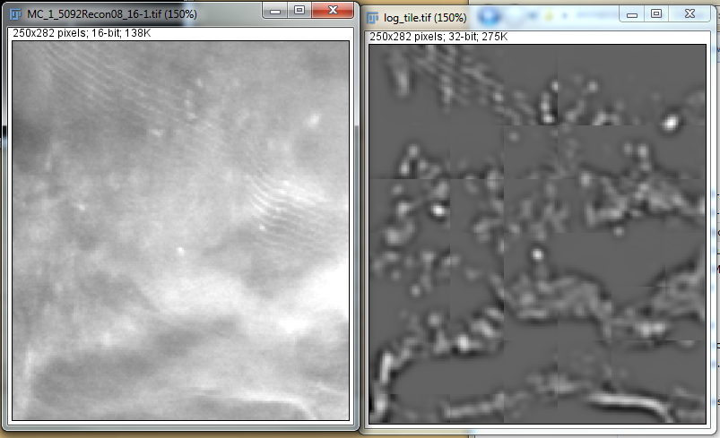

Figure : The image region before and after foreground extraction

After applying the LOG filter, we binaries the response image and use a label connect filter so that each calcification candidate is labeled as an object and specified with an id.

A very important step is to apply constrain on suspicious calcification based on prior knowledge. Particularly, micro-calcifications appear in clusters, thus local density is a crucial factor. Size of each calcification blob is also an important constrain in this scenario. Also, we have made use of the 3-d information in this case. The reason is that the detection using LOG is very sensitive to noise, especially random noises smoothed after preprocessing. But the repetition of noise pattern in adjacent slices is rare and almost impossible. Therefore, we consider appearance frequency within adjacent slices as another constrain. An example of the results of constraining is as shown in Figure 14 below.

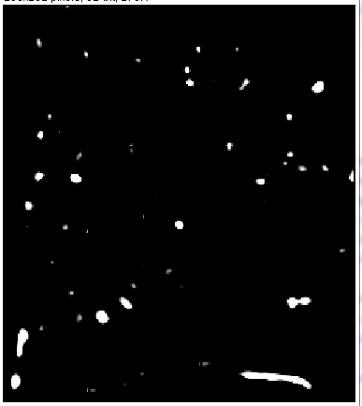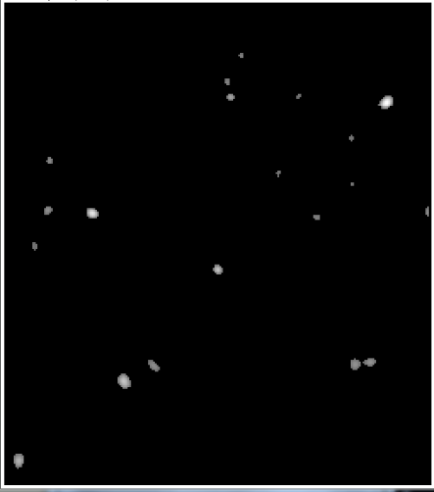

Figure : Filtering result before and after post constrain

By applying all steps above, The algorithm is able to detct micro-calcifications as a cluster, the result is shown below in Figure 15.

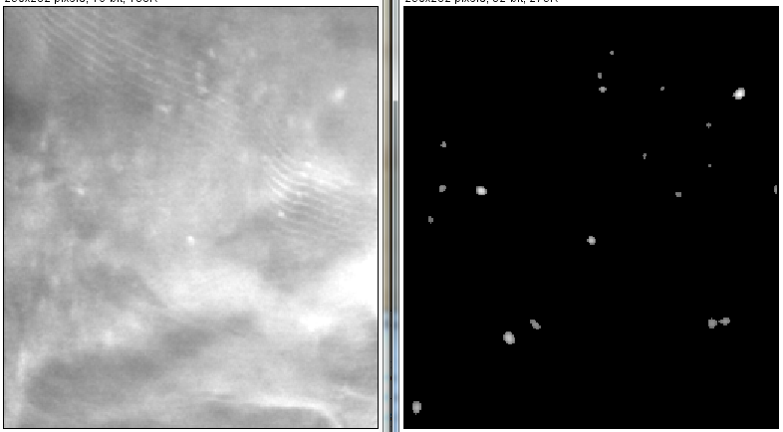

Figure : The original image and its Micro-calcification detection result

### Bilateral Asymmetric Detection

Very limited work has been done so far to detect bilateral asymmetrical in breast cancer. The main challenge in this task lies in the very first step, which is the registration (or alignment) of the breast for both the left and the right breast. The asymmetric of images from both sides is a consequence of two reasons. The absence of perfect symmetric in the breast, including asymmetric in shape, surface and architecture composes the major factor of bilateral asymmetric. Another reason is the process of image capturing. Images are captured in slightly different coordinates, different angles and different scales.

To solve the problem of bilateral asymmetric detection, we first address the problem of image registration using the thin plate spline theory. After images from both sides are aligned, we compare the two sides locally based on their intensity distribution and statistic information.

#### 3.7.1 Fiducial points extraction

In the image registration procedure, one of the crucial keys is to find proper and representative control points (or fiducial points in related literatures). Those fiducial points define the coordinates which control the mapping from the source image to the destination image. In our work, we choose the fiducail points that lie along the breast contour which delineates the surface of breast. The process follows the described steps below.

The first step is simply a flip of the image pixels so that they appear on the same side of the image. We detect the side of the breast simply based on the integrated intensity value on the upper left corner. It is preferred both sides converted to the left side so that the informative pixels start at pixel coordinate (0, 0).

The second step is to detect the contour of the breast. We are taking the advantage that in the dataset, background pixels are of value zero. Thus a simple thresholding will define the contour. (The fact is we don’t have to consider the artifact described in the mass detection section, because all we need is the location of the boundary, the intensity of the boundary is of no interest in this situation.)

We conduct a sampling step along the contour to collect the fiducail points. An evenly sampling along the contour gives us a set of points that controls the mapping process. Notice that before sample, the contour has to been cleared up so that it is smooth and pixel along the contour is unique (no back and forth in both axis). To guarantee that the transformation (described in the spline section) is unique and reversible. Another set of points are chosen. This set of points are located on the left border of the image, their y axis are selected equal as those in the fiducial points respectively. This set of control points makes sure there is no significant rotation in the transformation.

An example of the selected fiducial points is shown in Figure 16 below following the above steps.

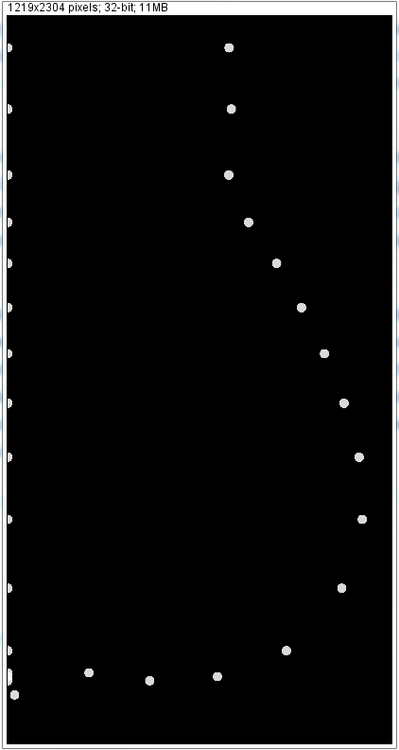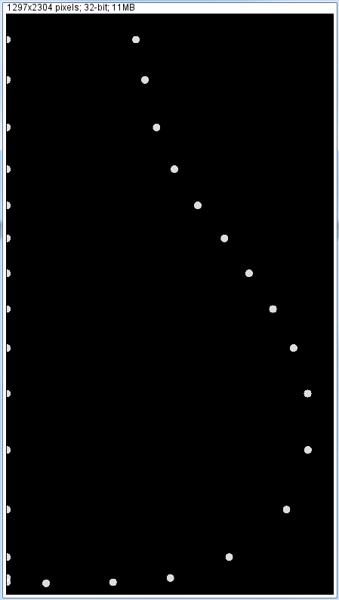

Figure : Selected control points set from both side of the breast images

#### 3.7.2 Thin Plate Spline Registration

Once the fiducial points are selected for controlling, the thin plate spline interpolation algorithm is used for image registration. The name thin plate spline refers to a physical analogy involving the bending of a thin sheet of metal. Just as the metal has rigidity, the TPS fit resists bending also, implying a penalty involving the smoothness of the fitted surface. In the physical setting, the deflection is in the z direction, orthogonal to the plane. In order to apply this idea to the problem of coordinate transformation, one interprets the lifting of the plate as a displacement of the x or y coordinates within the plane [30].

Despite the mathematical theory behind the algorithm, the numerical implementation is quite simple as described below.

Given a set of control points, the displacements of all other points in the image are determined by two terms, bending defined by the control points, and an affine terms defining mapping to the infinity.

In the formula, denotes the displacement at an arbitrary point , is the affine term which defines the mapping of points far away from the control points. The last term controls the bending influenced by each of the control point. The controlling function is a function of distance from the point of interest to the control points, defined as , where is the Euclidean distance . The solution to the linear system is derived by solving the above equation plugging the source and destination control points.

An example result is shown in Figure 17 below, where the subfigure on the left is the left breast, the figure in the center is the flipped right breast, and the third figure is the registered image of the left breast. As can been seen in the registered image, the textural and structural information are kept while the shape of the boundary are deformed toward the destination image.

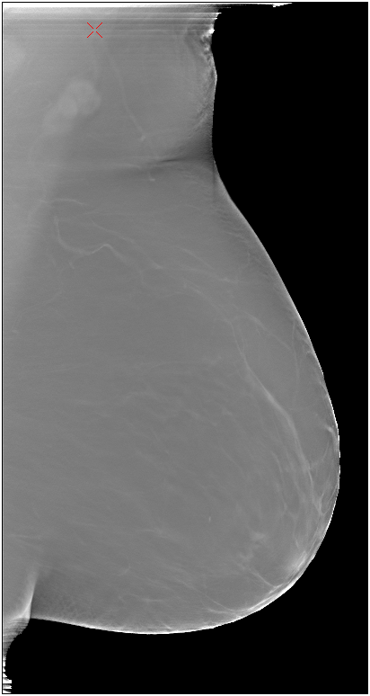 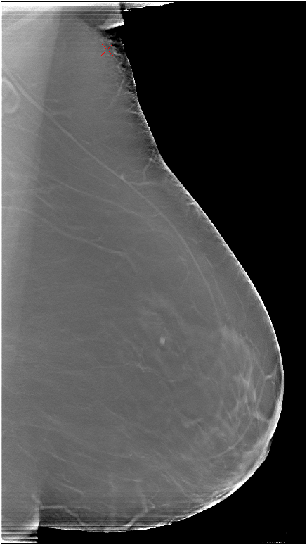 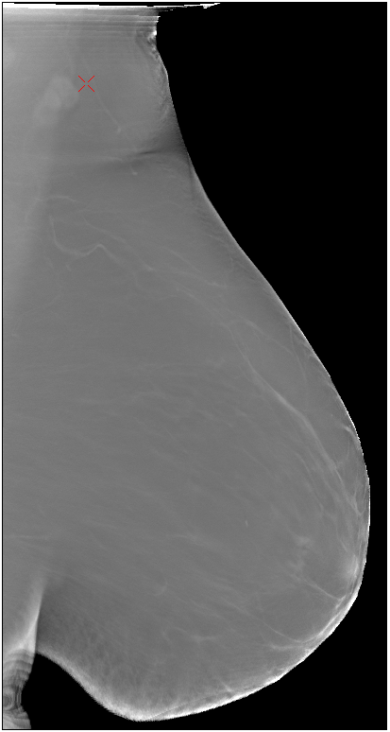

Figure : The horizontally flipped right breast (on the left), the left breast (in the middle), and the aligned right breast (on the right side)

#### 3.7.3 Corresponding Region Comparison

In order to find out the symmetricity of the two sides of the breast, we explore some distance metrics that are available for us to compare how similar two images regions are. After the alignment of images, we crop the image into fixed sized regions to create objects for comparison. (Regions were cropped with an overlap of half the size so that no boundary information is lost.)

The distance metric deployed can be categorized as intensity based and feature based. The intensity based metrics are computed based on intensity values’ distribution divergence, cross correlation of templates, etc. While the feature based metrics extract representative features such as principal components as a first step, and traditional distance for feature vectors are then utilized as the final distance metric.

**Intensity based metric:**

To compare the similarity of the two image regions, we first convert the image matrices into 1-D arrays, from which histograms are formulated. (Note that a trivial normalization step is conducted before the following computation to avoid the inconsistence between images.) A few basic distances are included such as “Euclidean”, "Manhattan", and "Chebysev". More advanced distances like Pearson correlation, Chi-Square correlation, intersection and Bhattacharyya distance are also included in our framework. Besides, we have included the classic Kullback–Leibler divergence as a similarity measure.

We also compare the two regions as two matrices. For this, we use the template matching techniques including normalized SQDIFF, normalized cross correlation, the equations are given below:

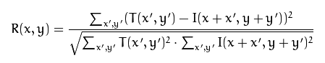 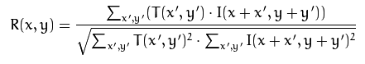

**Feature based metric:**

Apart from the intensity and spatial distribution provided from each of the image crops, we also are interested in the geometric characteristics existing in the pixels. (In our case, this appeared to be the vascular structures, etc.) We used simple principal components decomposition and non-negtive matrix factorization as two ways of extracting such kind of principal vectors. Only the first few principal components (or factors) are used for comparison.

## Conclusion & Future Work

Breast tomosynthesis is a breakthrough in [mammography](http://www.massgeneral.org/imaging/services/procedure.aspx?id=2252) that provides a clearer, more accurate view compared to digital mammography alone. It allows specialized breast radiologists to see through layers of tissue and examine areas of concern from all angles.

We develop our computer aided diagnosis toolkit based on the multi layers tomosynthesis images. In our work, we “diagnosis” early sign of breast cancer from detection of speculated masses, micro-calcifications, and bilateral asymmetric, which covers most of the characteristics occur in an early stage of breast cancer. Our frame work shows promising result for sample dataset with good quality. For example, the mass initial detection is able to detect suspicious areas in which there are real masses, vascular intersections and other high intensity irregular shaped object. The false positive regions are supposed to be reduced in a further classification procedure. Another example is the successful alignment of the images from both side of the breast.

However, our work is limited by a number of factors. Lacking of sufficient training data is one of the major factors. This is essentially important in the classification stage where a large number of samples are required to learn the patterns of the real suspicious patterns.

In all, this framework serves as a proposal and an explorative methodology sets for future works. More data provided, there are several parts can be significantly modified to improve the accuracy. These parts include feature extraction in Section 3.4. The current feature set is intuitive and representative for the dataset we have in hand. But the data we have do not include all possible clinical cases. Section 3.5 can be modified or totally replaced by other classification techniques. The bilateral asymmetric analysis is not entirely complete. We have the registration algorithm and region comparison algorithm in our frame work. But we have no knowledge of what asymmetric level will raise the alarm, given that we don’t have image cases labeled in this category.

More importantly, our framework is based on individual slice detection; we achieve our final diagnosis based on adjacent consistency and spatial relationship. In future work, this might be done by applying 3-d detection algorithms directly on the image stacks.

## Acknowledgement

This project is conducted under the collaboration of Concordia University, MGH and SAP. Special thanks to Prof. Moore, Richard H., Prof. Kopans, Daniel B., Prof. Ching Y. Suen, and Ellenberger, John.

Thanks to [Mina Yusefi](mailto:myusefi64@gmail.com), Caitlin Mehl, Hussain, Ishrar, and Huang, Juhua.

## References

[1] <http://en.wikipedia.org/wiki/Breast_cancer>

[2] <http://en.wikipedia.org/wiki/Tomosynthesis>

[3] <http://www.breastcancer.org/symptoms/testing/types/dig_tomosynth>

[4] <http://www.massgeneral.org/imaging/services/3D_mammography_tomosynthesis.aspx>

[5] Sickles, EA, D’Orsi CJ, Bassett LW, et al. ACR BI-RADS® Mammography. In: *ACR BI-RADS® Atlas, Breast Imaging Reporting and Data System*. Reston, VA, American College of Radiology; 2013.

[6] <http://www.ladycarehealth.com/types-and-causes-of-breast-calcifications/>

[7] Rangayyan, Rangaraj M., Fabio J. Ayres, and J. E. Leo Desautels. "A review of computer-aided diagnosis of breast cancer: Toward the detection of subtle signs." *Journal of the Franklin Institute* 344.3 (2007): 312-348.

[8] http://www.conciergeradiologist.com/abnormal-mammogram.html

[9] Vieira, Marcelo AC, Predrag R. Bakic, and Andrew DA Maidment. "Effect of denoising on the quality of reconstructed images in digital breast tomosynthesis." *SPIE Medical Imaging. International Society for Optics and Photonics*, 2013.

[10] Anscombe, Francis J. "The transformation of Poisson, binomial and negative-binomial data." *Biometrika* (1948): 246-254.

[11] V. I. Ponomarev and A. B. Pogrebniak, "Adaptive Wiener Filter Implementation for Image Processing," in *MMET*, 1996.

[12] <http://en.wikipedia.org/wiki/Gabor_filter>

[13] Heil, Christopher E., and David F. Walnut. "Continuous and discrete wavelet transforms." *SIAM* review 31.4 (1989): 628-666.

[14] Zhang, Yiheng, et al. "Application of boundary detection information in breast tomosynthesis reconstruction." *Medical physics* 34.9 (2007): 3603-3613.

[15] Márquez-Neila, Pablo, Luis Baumela, and Luis Alvarez. "A morphological approach to curvature-based evolution of curves and surfaces." (2013): 1-1.

[16] Álvarez, Luis, et al. "Morphological snakes." Computer Vision and Pattern Recognition (CVPR), *2010 IEEE Conference on*. IEEE, 2010.

[17] Sahiner, Berkman, et al. "Computerized characterization of masses on mammograms: The rubber band straightening transform and texture analysis." *Medical Physics* 25.4 (1998): 516-526.

[18] Sahiner, Berkman, et al. "Improvement of mammographic mass characterization using spiculation measures and morphological features." *Medical Physics* 28.7 (2001): 1455-1465.

[19] Chan, Heang-Ping, et al. "Characterization of masses in digital breast tomosynthesis: Comparison of machine learning in projection views and reconstructed slices." *Medical physics* 37.7 (2010): 3576-3586.

[20] Tourassi, Georgia D., David M. Delong, and Carey E. Floyd Jr. "A study on the computerized fractal analysis of architectural distortion in screening mammograms." *Physics in medicine and biology* 51.5 (2006): 1299.

[21] Haghighat, Mohammad Bagher Akbari, Ali Aghagolzadeh, and Hadi Seyedarabi. "A non-reference image fusion metric based on mutual information of image features." *Computers & Electrical Engineering* 37.5 (2011): 744-756.

[22] Elfarra, Belal K., and Ibrahim SI Abuhaiba. "New feature extraction method for mammogram computer aided diagnosis." International Journal of Signal Processing, *Image Processing and Pattern Recognition* 6.1 (2013).

[23] Al-Shamlan, Hala, and Ali El-Zaart. "Feature extraction values for breast cancer mammography images." *Bioinformatics and Biomedical Technology (ICBBT), 2010 International Conference on*. IEEE, 2010.

[24] Pradeep, N., et al. "Feature extraction of mammograms." *International Journal of Bioinformatics Research*, ISSN (2012): 0975-3087.

[25] Leistner, Christian, Amir Saffari, and Horst Bischof. "MIForests: Multiple-instance learning with randomized trees." *Computer Vision*–ECCV 2010. Springer Berlin Heidelberg, 2010. 29-42.

[26] Blockeel, Hendrik, David Page, and Ashwin Srinivasan. "Multi-instance tree learning." *Proceedings of the 22nd international conference on Machine learning. ACM*, 2005.

[27] Dundar, M. Murat, et al. "Multiple-instance learning algorithms for computer-aided detection." Biomedical Engineering, *IEEE Transactions on* 55.3 (2008): 1015-1021.

[28] http://en.wikipedia.org/wiki/Blob_detection

[29] Hanmandlu, Madasu, et al. "Computer aided detection of suspicious masses and micro-calcifications." *Information Technology: New Generations, 2008. ITNG 2008. Fifth International Conference on*. IEEE, 2008.

[30] Bookstein, Fred L. "Principal warps: Thin-plate splines and the decomposition of deformations." *IEEE Transactions on pattern analysis and machine intelligence* 11.6 (1989): 567-585.